 | 12.1.8 Editors - Geometry Nodes Editor - Header - Add Menu - Geometry
Table of content
Detailed table of content 1
Add menu - Geometry 1
Bounding Box 2
Join Geometry 2
Transform 2

Detailed table of content
Detailed table of content
Detailed table of content 1
Add menu - Geometry 1
Bounding Box 2
Inputs 2
Geometry 2
Output 2
Mesh 2
Min 2
Max 2
Join Geometry 2
Inputs 2
Geometry 2
Output 2
Geometry 2
Transform 2
Inputs 3
Geometry 3
Translation 3
Rotation 3
Scale 3
Output 3
Geometry 3

Add menu - Geometry
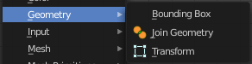
Here you find nodes to modify the geometry.

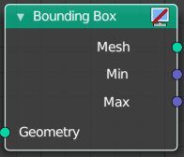
Bounding Box
The Bounding Box geometry node allows you to work with the values of a bounding box.

Inputs

Geometry
Standard geometry input.

Output

Mesh
Standard mesh output.

Min
The minimum values of the bounding box.

Max
The maximum values of the bounding box.

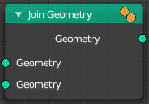
Join Geometry
The Join Geometry enables you to merge separately generated pieces of geometry into a single one. In case that the inputted pieces contain different types of geometry, the output will contain multiple types of geometry.

Inputs

Geometry
Standard geometry input.

Output

Geometry
Standard geometry output.

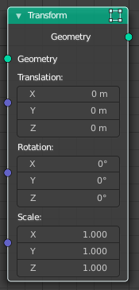
Transform
Move, rotate or scale the geometry. The transformation is applied to the entire geometry, and not per element. For example, you can not rotate individual point cloud points with this node.

Inputs

Geometry
Standard geometry input.

Translation
Translates the geometry in local space of the modified object.

Rotation
Euler rotation in local space.

Scale
Scale to transform the geometries in local space.

Output

Geometry
Standard geometry output.

